Assignment 17.2

Write a secondary sort program to generate the top 2 maximum temperatures corresponding to every year from the temperature dataset.

Driver Class:

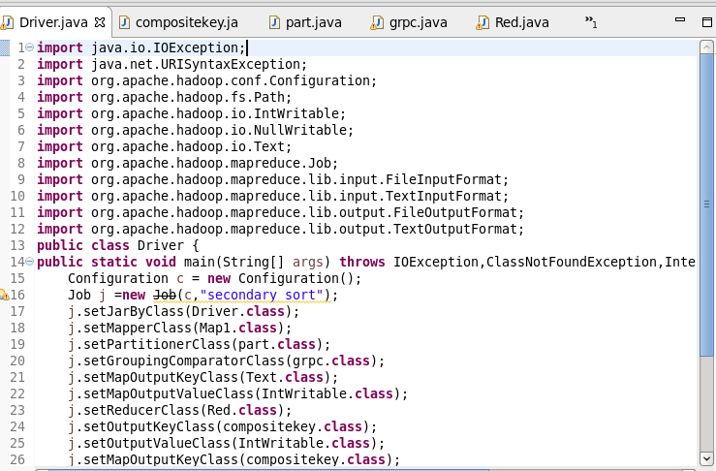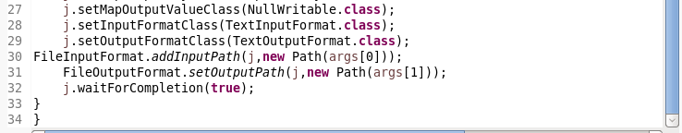

In DRIVER class, setting MAPPER CLASS,PARTITIONER CLASS, GROUP COMPARATOR CLASS , COMPOSITE KEY CLASS as MAP OUTPUT CLASS, REDUCER CLASS.

Mapper Class:

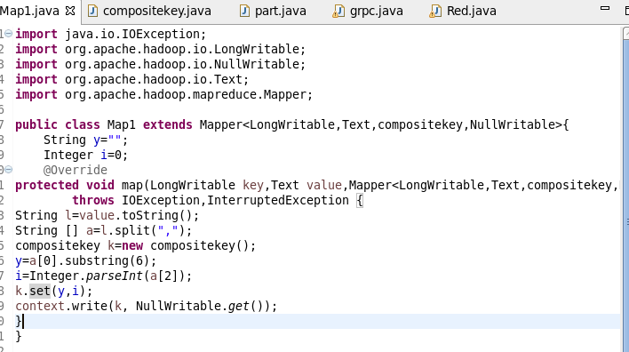

Here, In mapper class splitting the data by comma and then sending compositekey as key and value as nullwritable.

Compositekey class:

Here, overriding compareto and toString methods and also reading and writing the fields are happening.

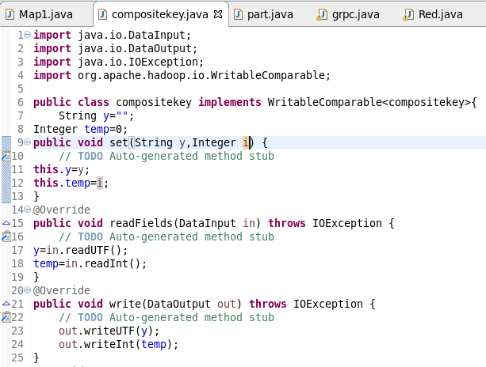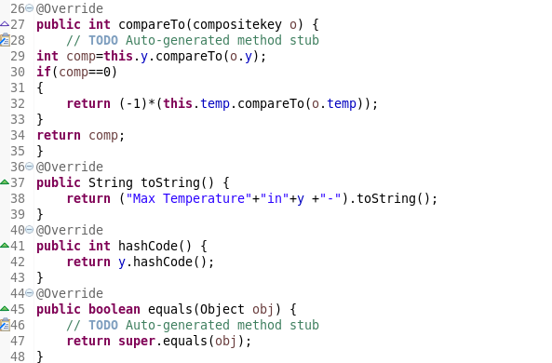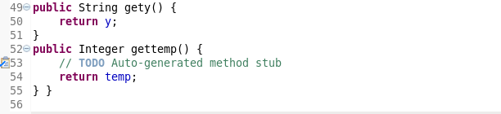

Partition class:

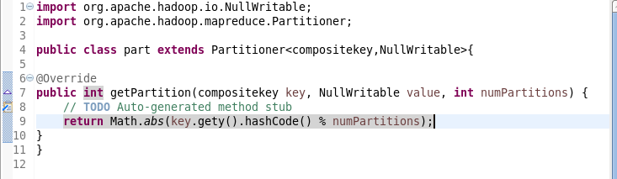

Here, in partition class sending the key-value pair from mapper to reducer.

Groupcomparator class:

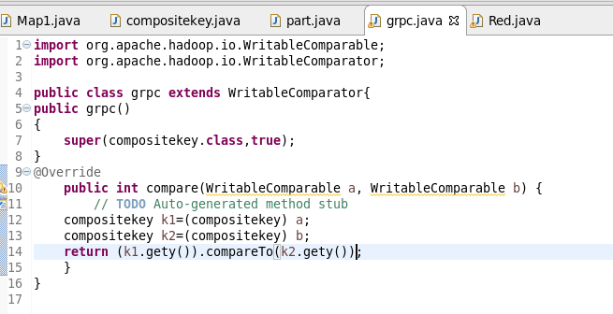

Reducer class:

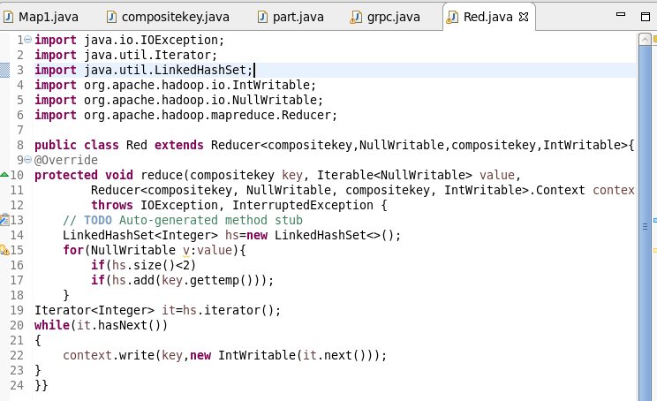

To get two maximum tempertare I am using linkedhashmap of size 2.

Output :

